**Prompt:** each >>> line

**Console:** the whole box as below

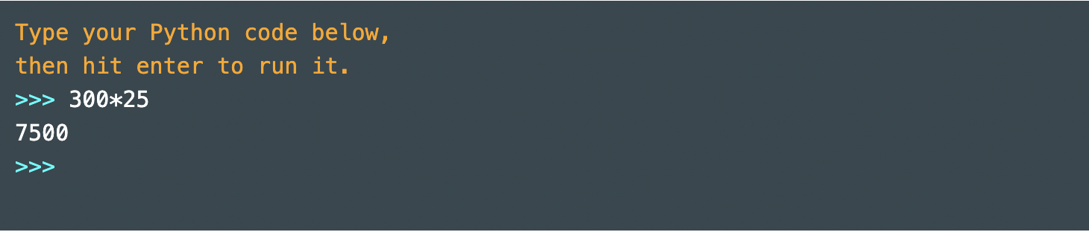

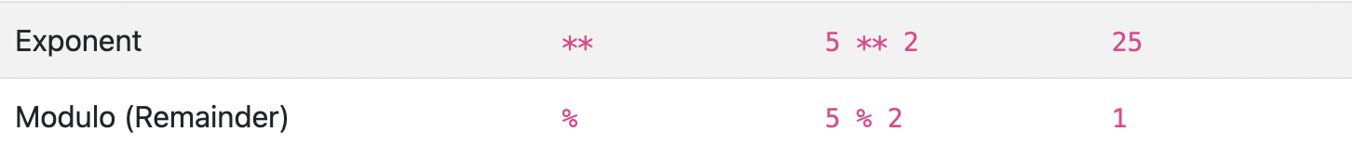

**Text-Quotes:** double or single quotes doesn’t matter; if we use double quotes, Python will respond with single quotes

Eg. “Hello”/‘Hello’

**Add Words together:**

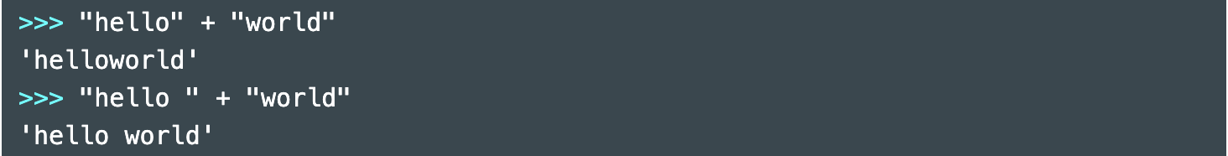

**Add Strings & Numbers:**

Requires Step 1/Step 2

Turn Number to String:

1. 9---str(9)
2. 9---“9”

**Functions:**

**len():** count letters in a string

String: len(“hi”)

Number: len(“3”) len(3)错的

**type():** check data type

这时候想看数字的话不用打引号，因为如果“10000”data type测出来就是string

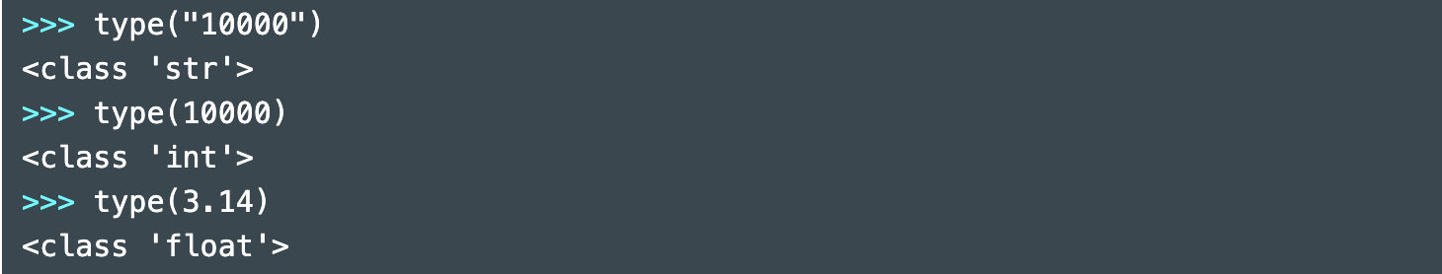

***

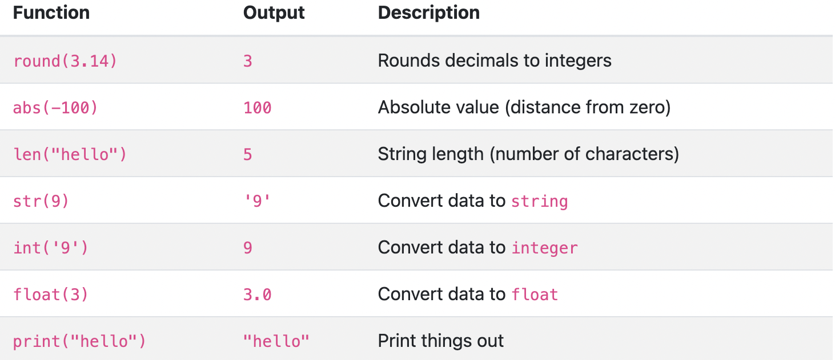

**保留几位小数：**

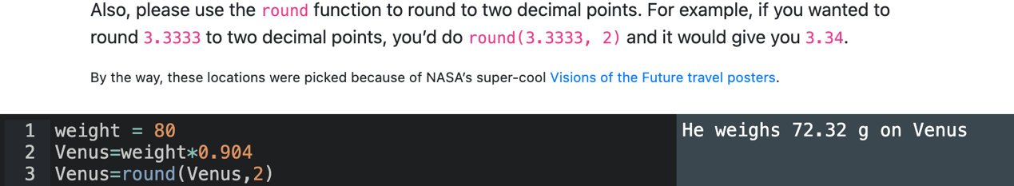

**Float/Floating Point Number≈小数**

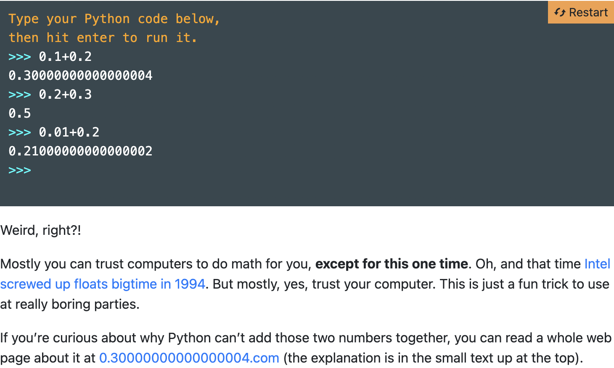

**Print: Use Commas to Separate things to be printed**

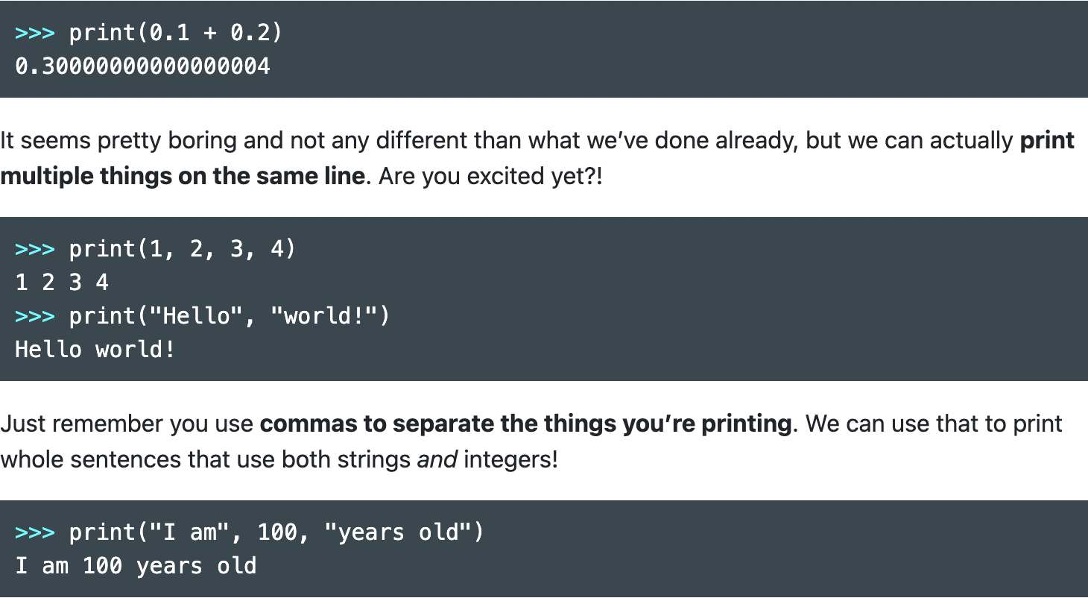

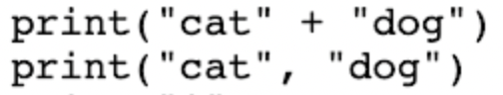

**加号拟合：catdog，逗号空格：cat dog**

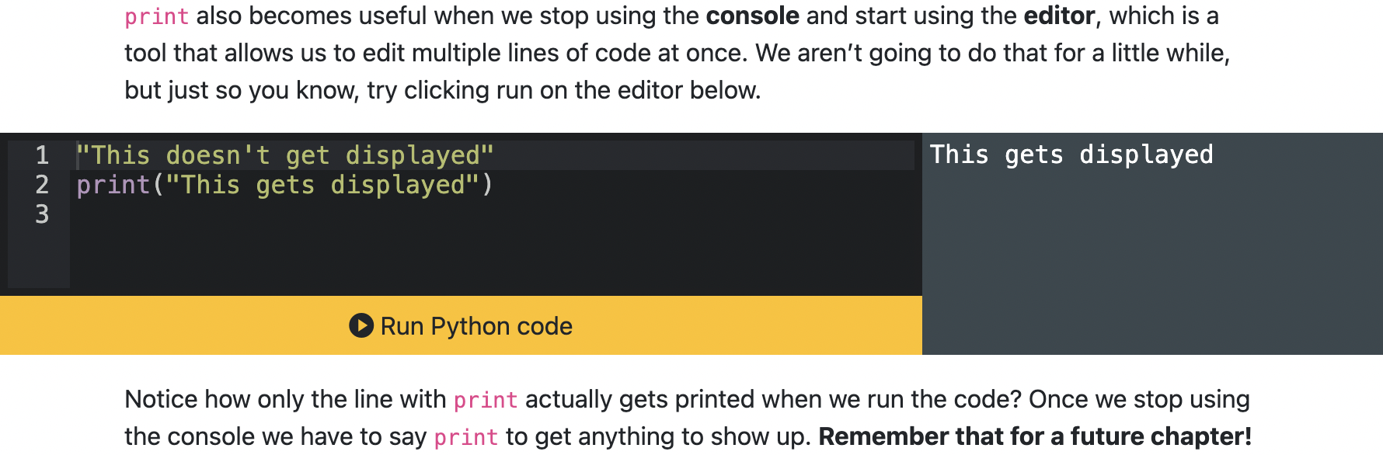

**Indentation Decides what to be/not to be printed out:**

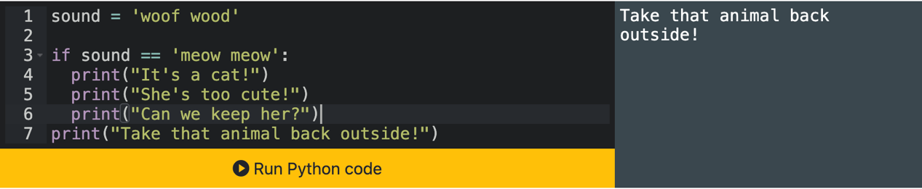

**Variables-Naming Data: can’t put spaces in a variable name** Eg. minutes_in_a_year

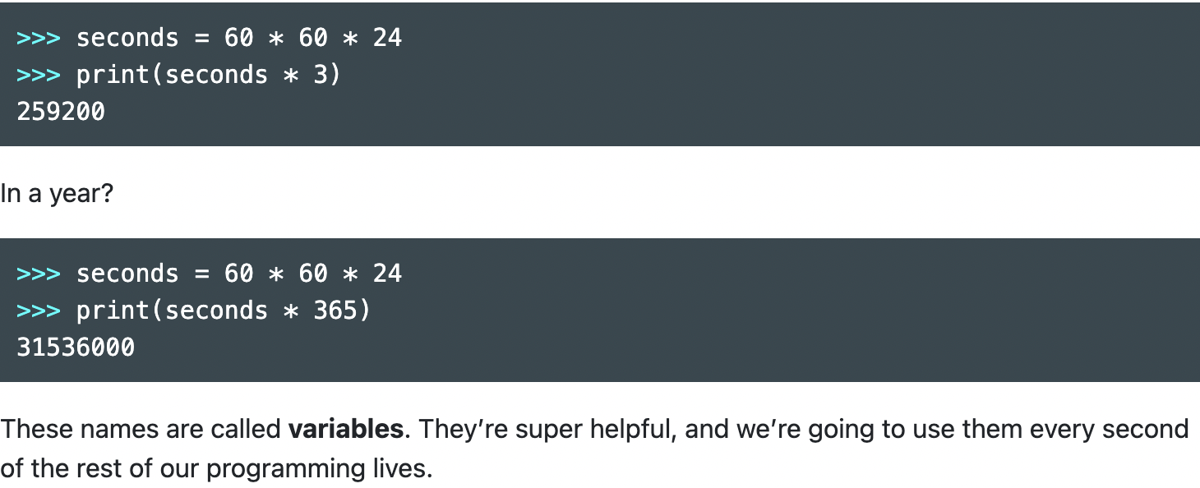

**\*\*\***

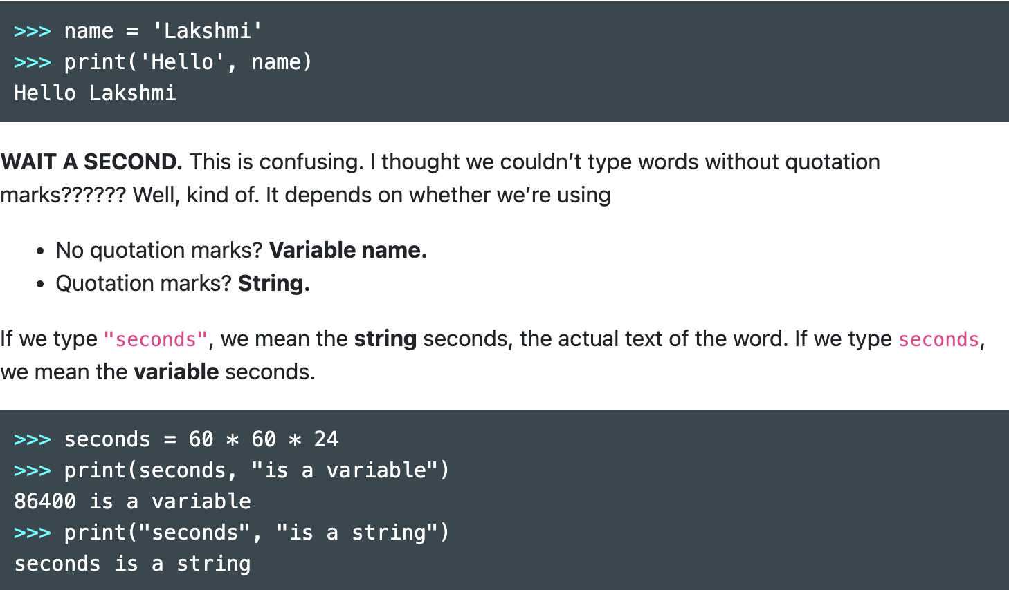

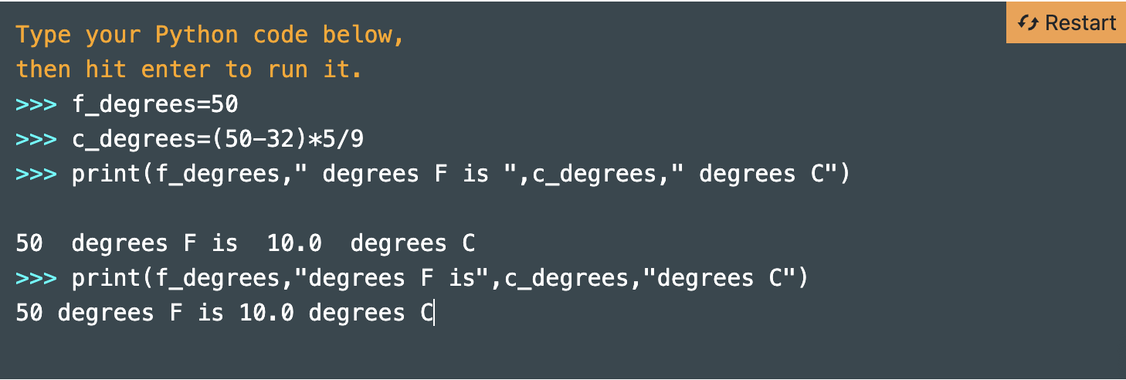

**If Statement/Conditional:**

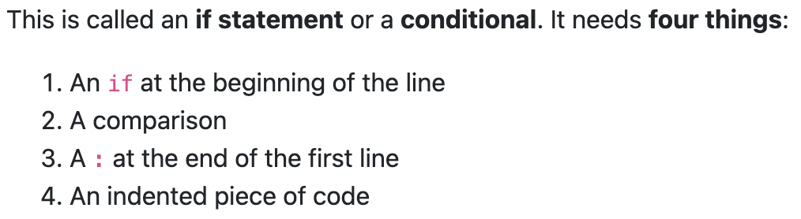

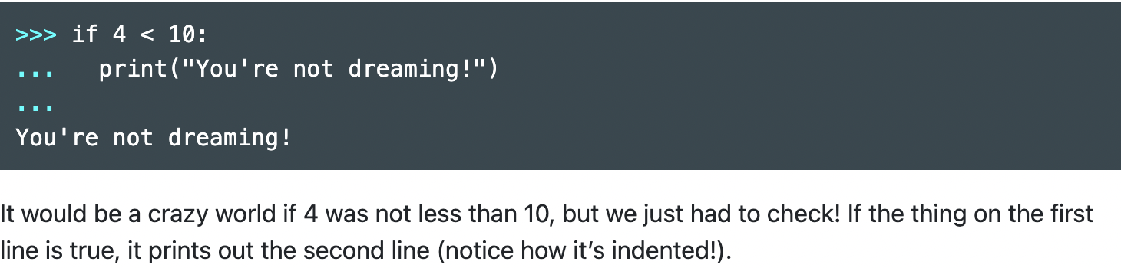

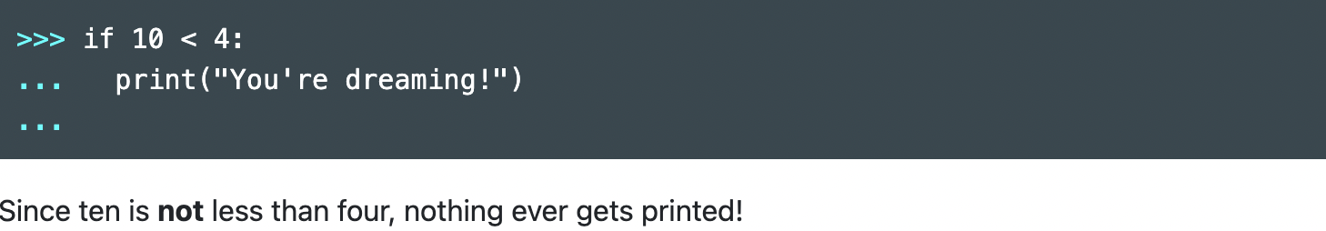

**Compare Numbers:** if 4**<**10:

**Compare Number&String:** if age**>=**18

**Compare Strings:** 双等号 **= =**



**Find Median:**

import statistics

median = statistics.median(numbers)

**If-Else:**

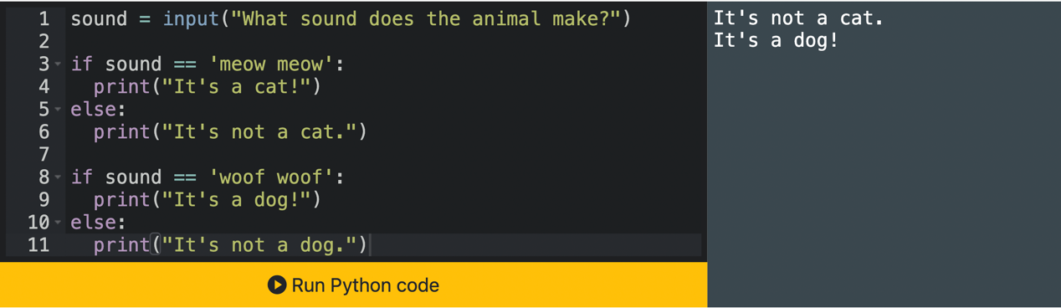

两个if之间是大并列关系

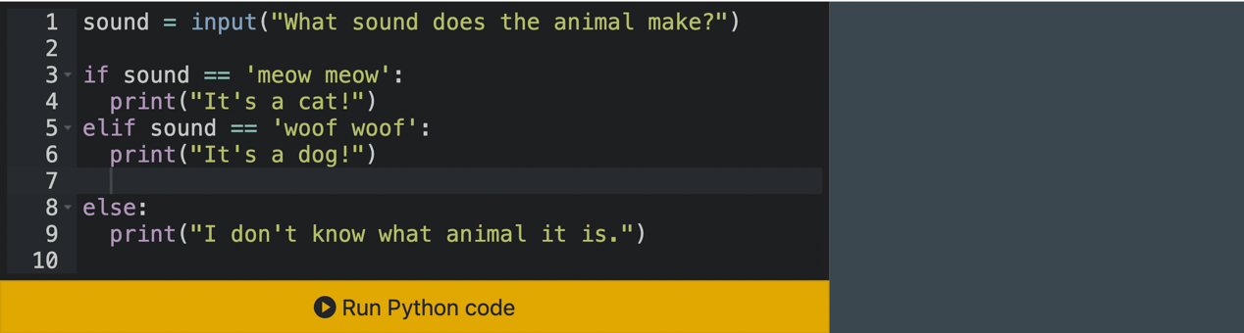

If和elif是或的关系，else是除if&elif外的所有其他

**Input: asks users questions**

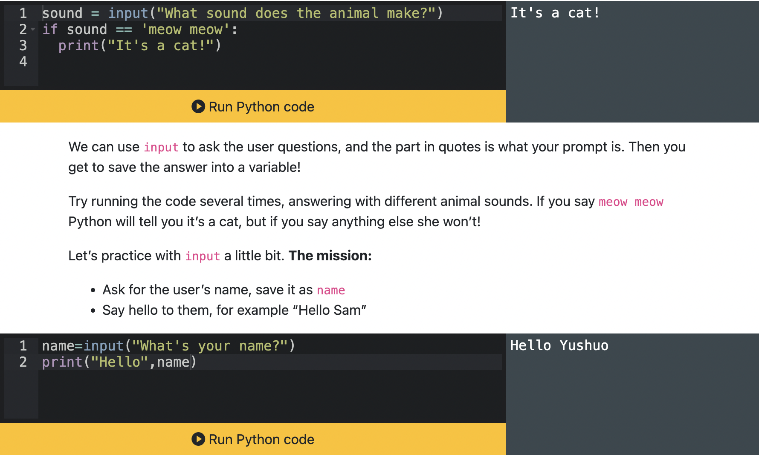

**Convert Variable Type:**

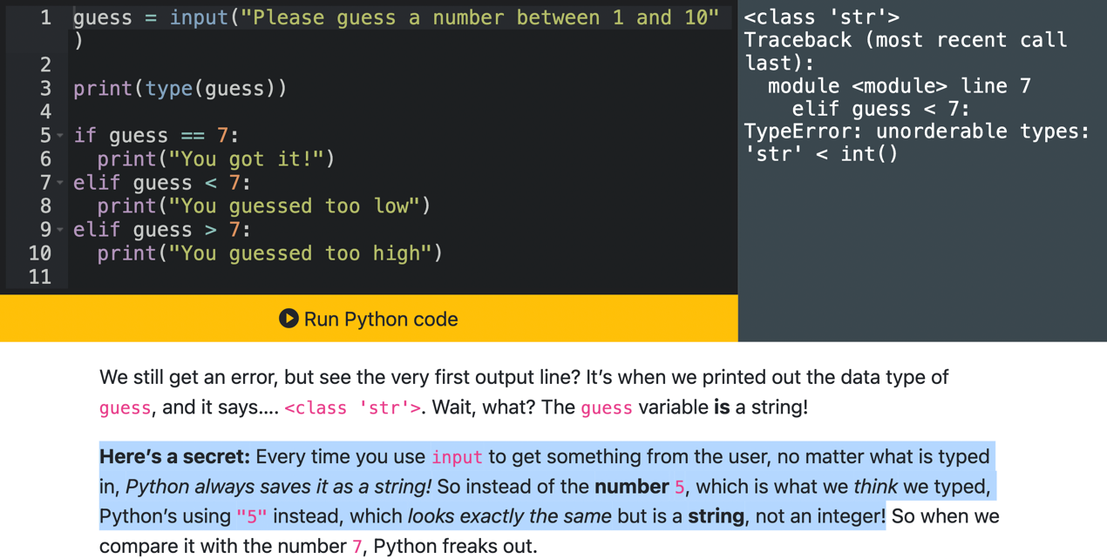

**Changed:**

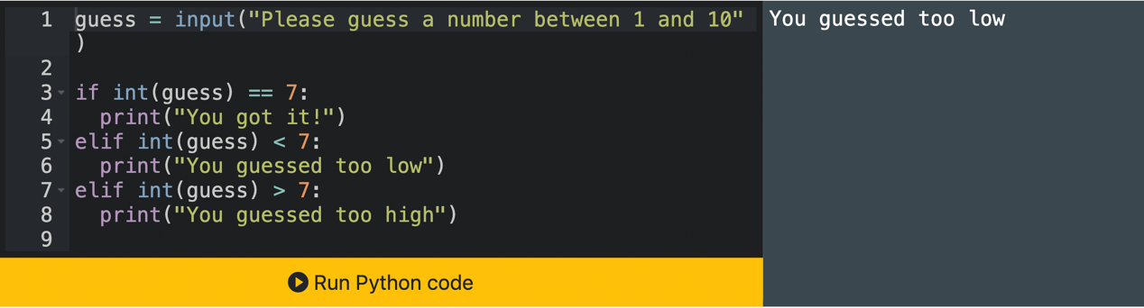

**或：**

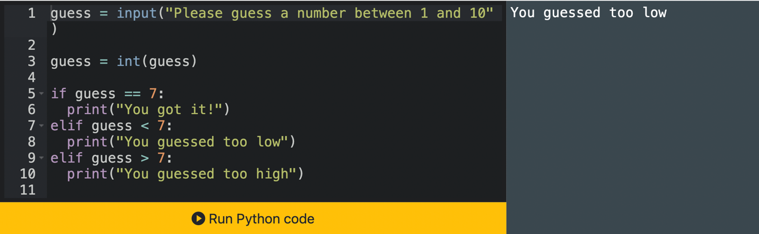

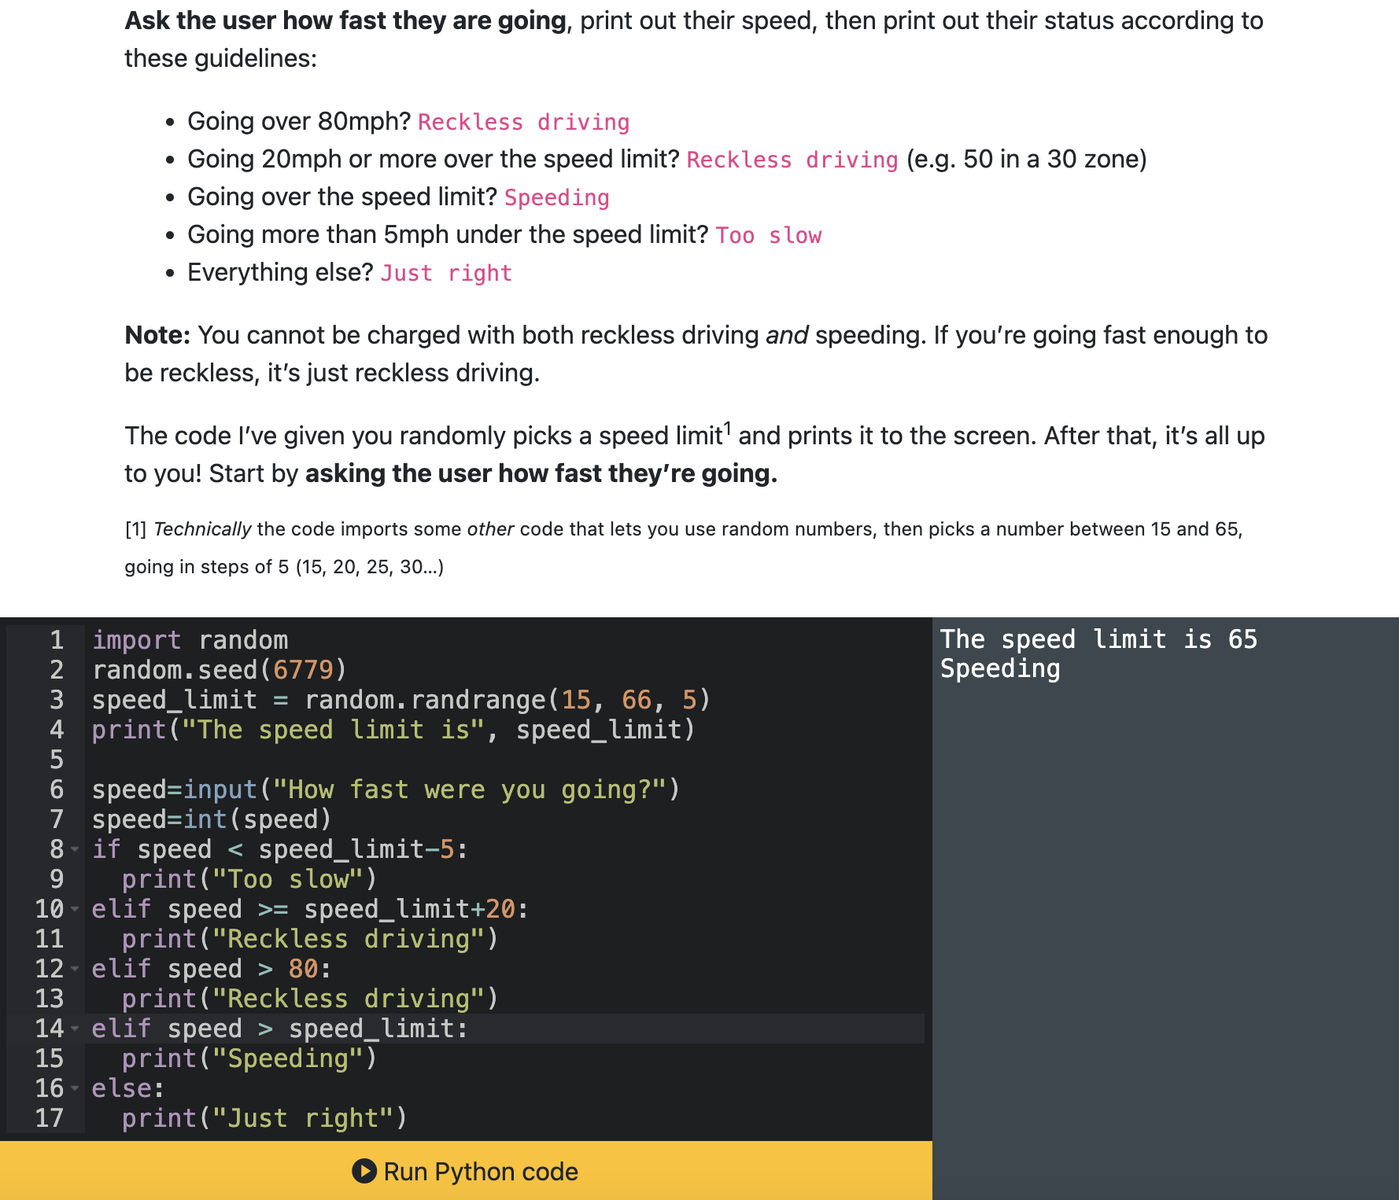

码是按照从上到下次序依次跑：Speeding必须放在Reckless driving后面，否则先定为Speeding了

**Changing Variables:**

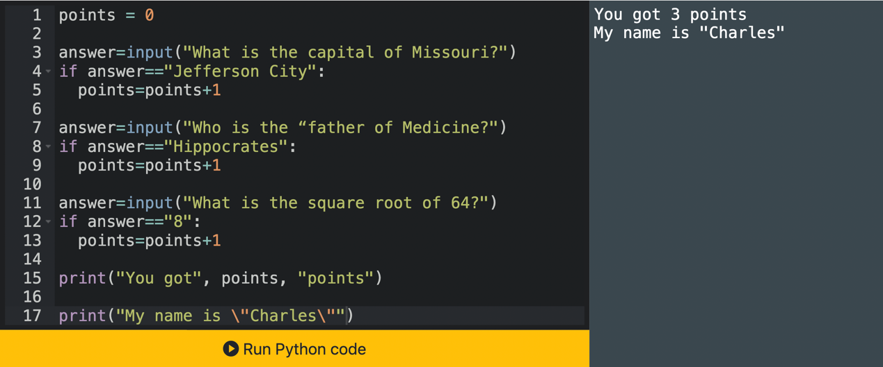

Input Result is String，所以8必须带引号

**Lists: with [] and Commas**

list: [7,14,3]

**Max of a list: max([** 7, 14, 3 **])，或者去掉【】**如max(7,14,3)/min(7,14,3)

**Create List: numbers = list(range(1,21))**

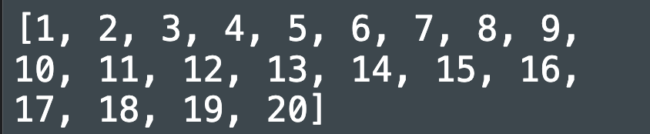

**Count the Length of Lists:**

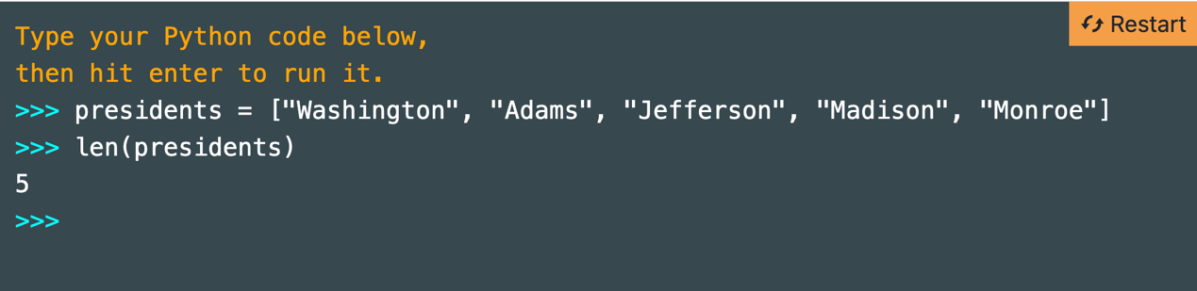

**第几项：**

**-正数：print(presidents[0])**

**-倒数：倒数第一print(presidents[-1])（没有-0这种写法）**

**Upper Case/Lower Case: .upper() / .lower()**

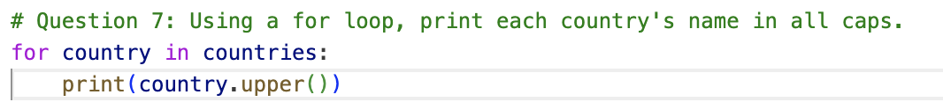

**Sort a List:**

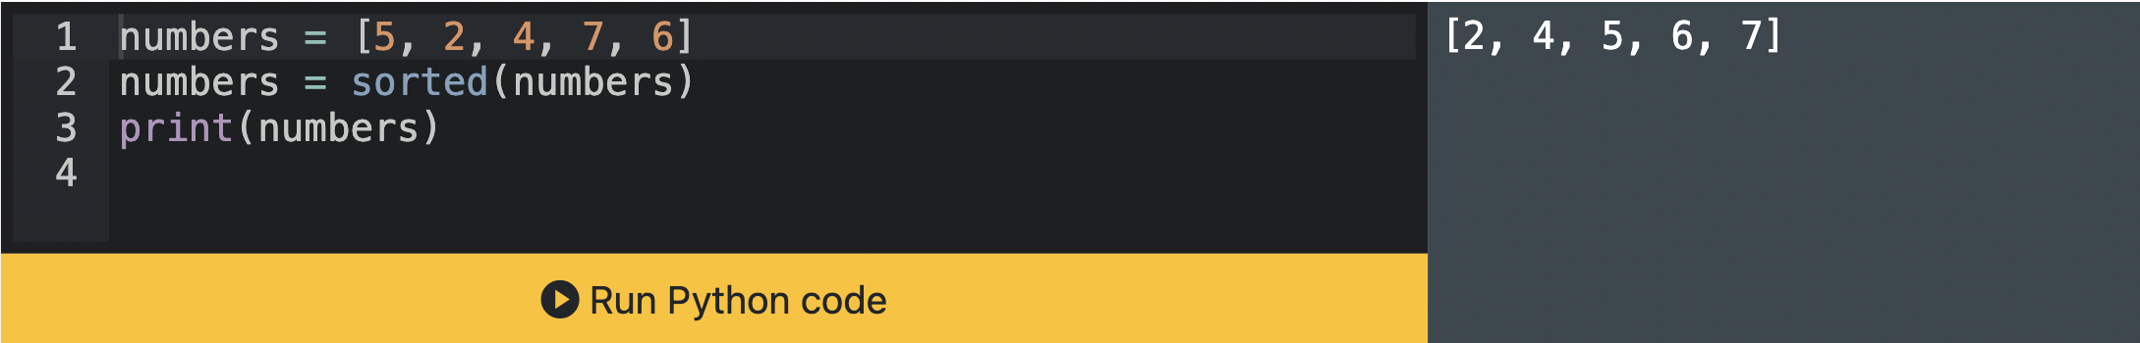

**Get a Part of a list:**

**z[1: ] 第一项之后到结尾的**

**z[:-1] all the way to the last one but not the last one**

**z[0:-1] all the way to the last one but not the last one**

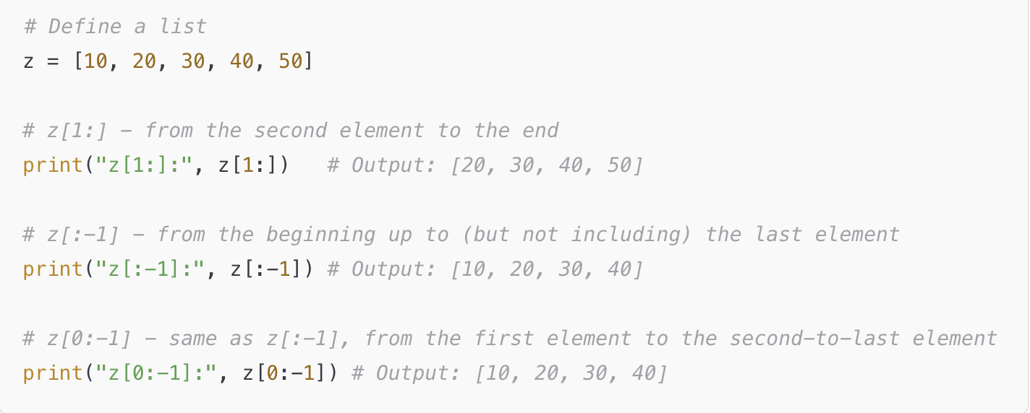

**Remove an item from the list:**

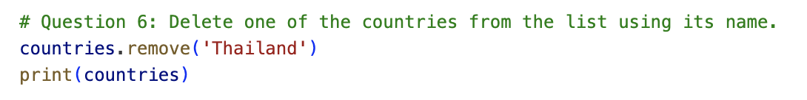

**For Loop (List进阶版)：**

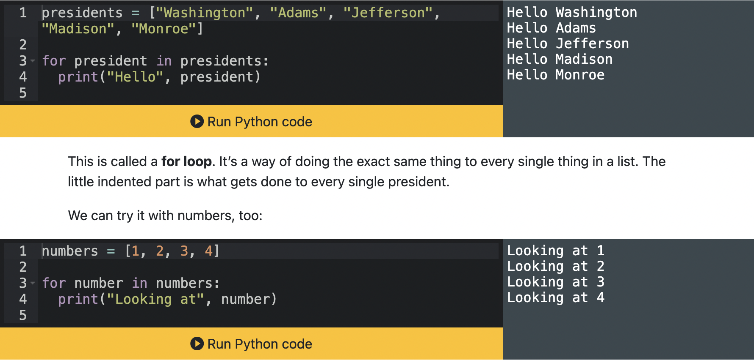

President/number是我们自己可以随意取的名字

president/number是我们自己可以随意取的名字



**注意必须要indent print line否则print不是下属于for loop了**

**Indentation Matters:**

**对比⬇️**

1. **Loop全跑完了出来再Print**

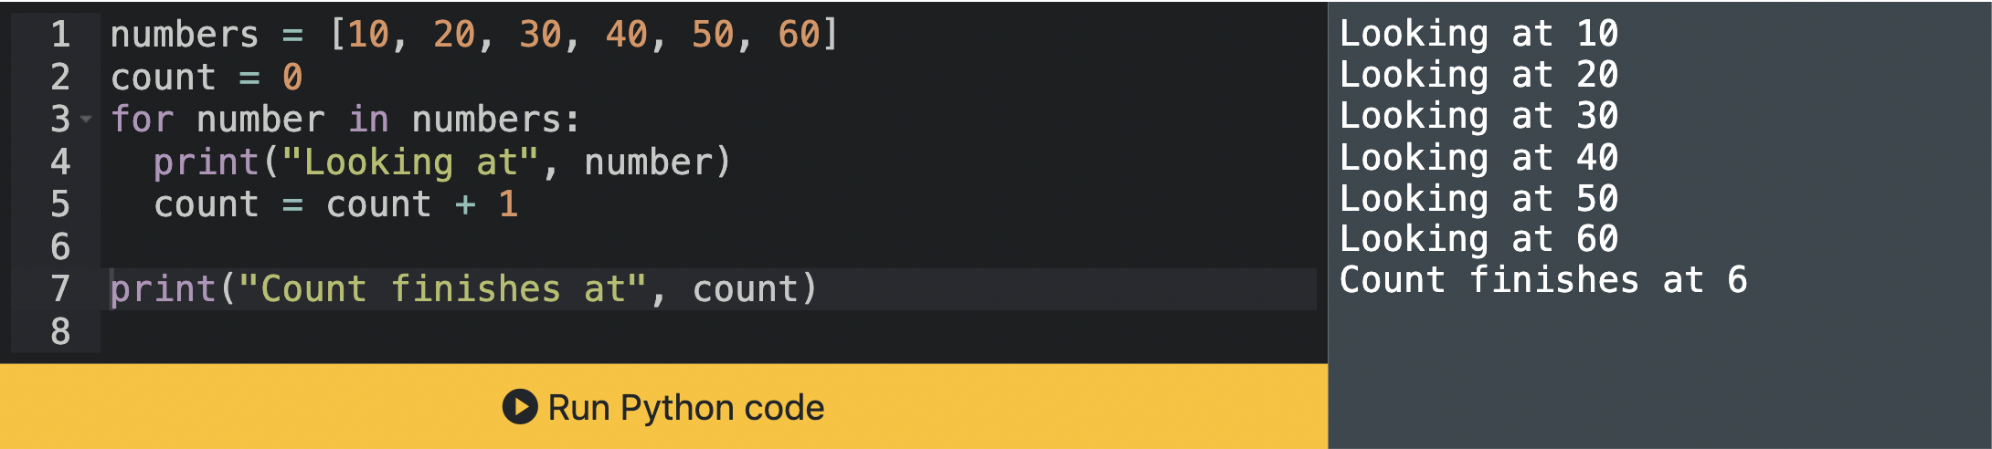

1. **Print是每个Loop循环的一部分**

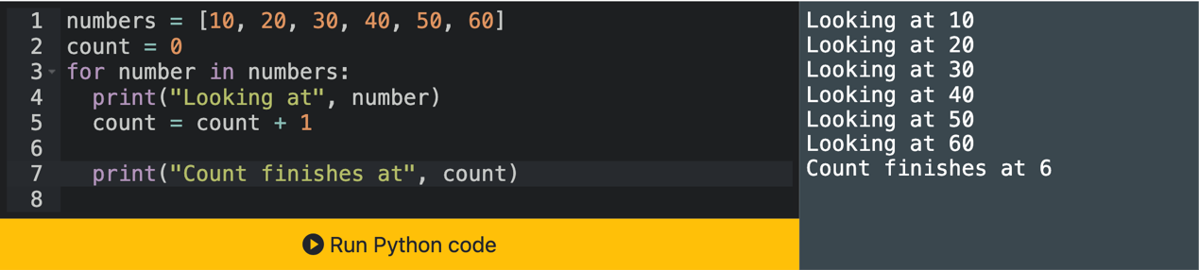

**.startswith**

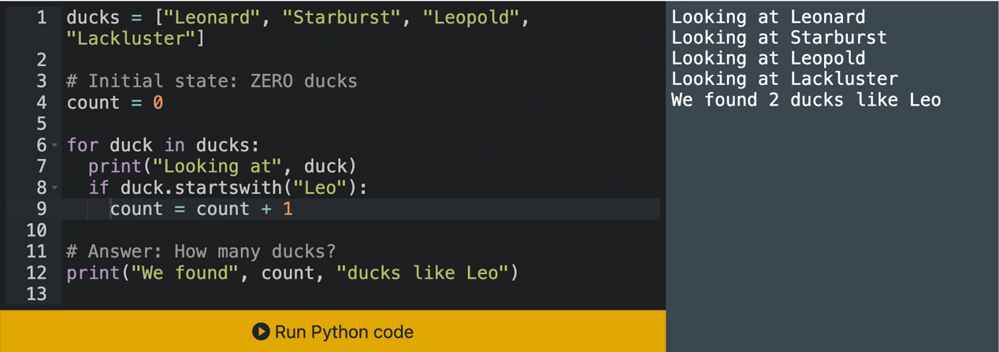

所有if statement(哪怕如这个if已经indent)，伴随的后续码(count=count+1)都必须新加indentation

**Initial State Matters:**

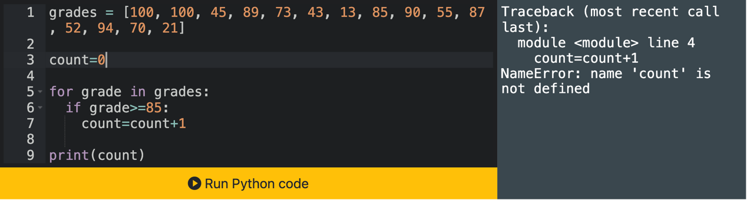

所有Loop内部的Variable(如grade尤其count)，必须在Loop外被定义过(count=0)

**Percentage of the class that received an 85 or higher:**

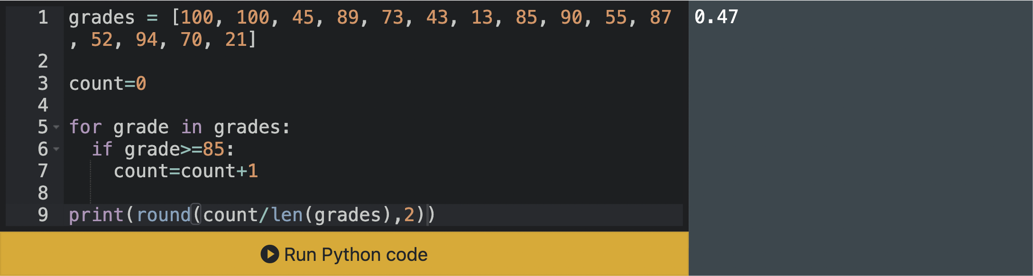

**Dictionary:**

**整体：dictionaryname = {‘xx’: ‘abc’, ‘x’: 1, ‘xxx’: ‘cb’}**

**各项：annie[‘xx’] / annie[‘x’]**

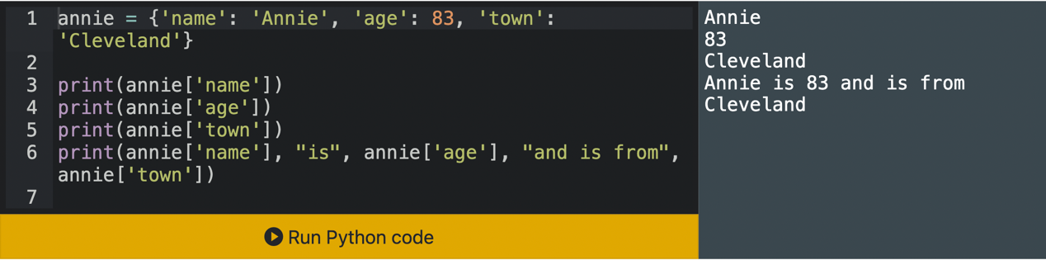

**Dictionary VS List:**

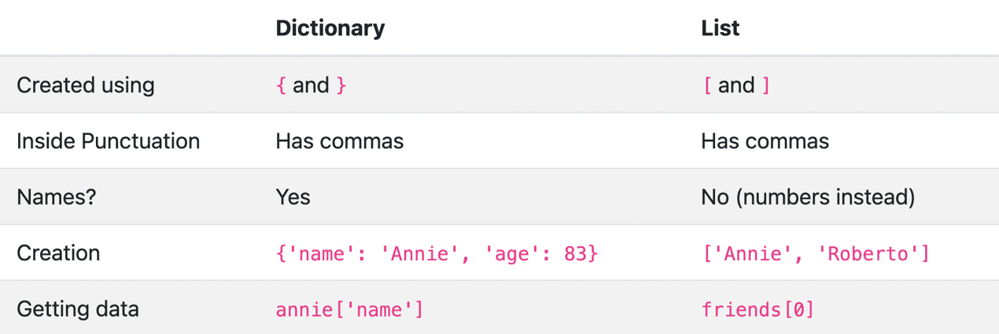

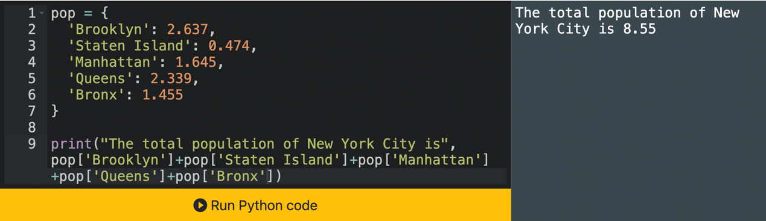

We can’t do pop['Brooklyn' + 'Manhattan'], because the strings get combined first. It would be like typing pop['BrooklynManhattan']

**Add New Variables to Dictionaries:**

**数字：**

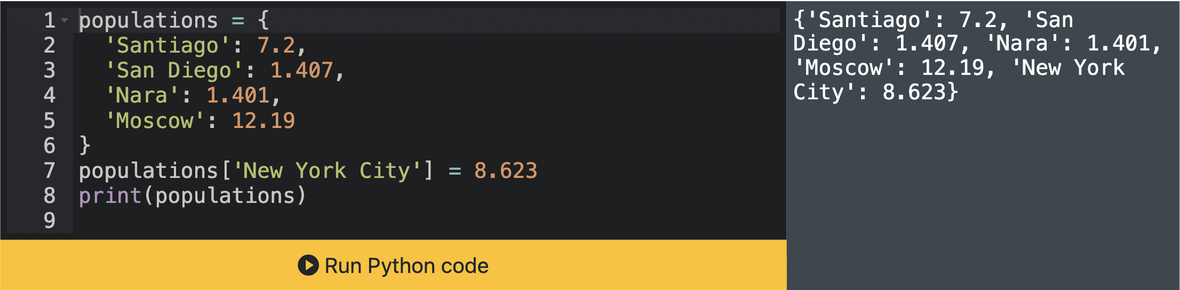

values

keys

**print(annie.keys())——dict_keys(['name','age','town'])**

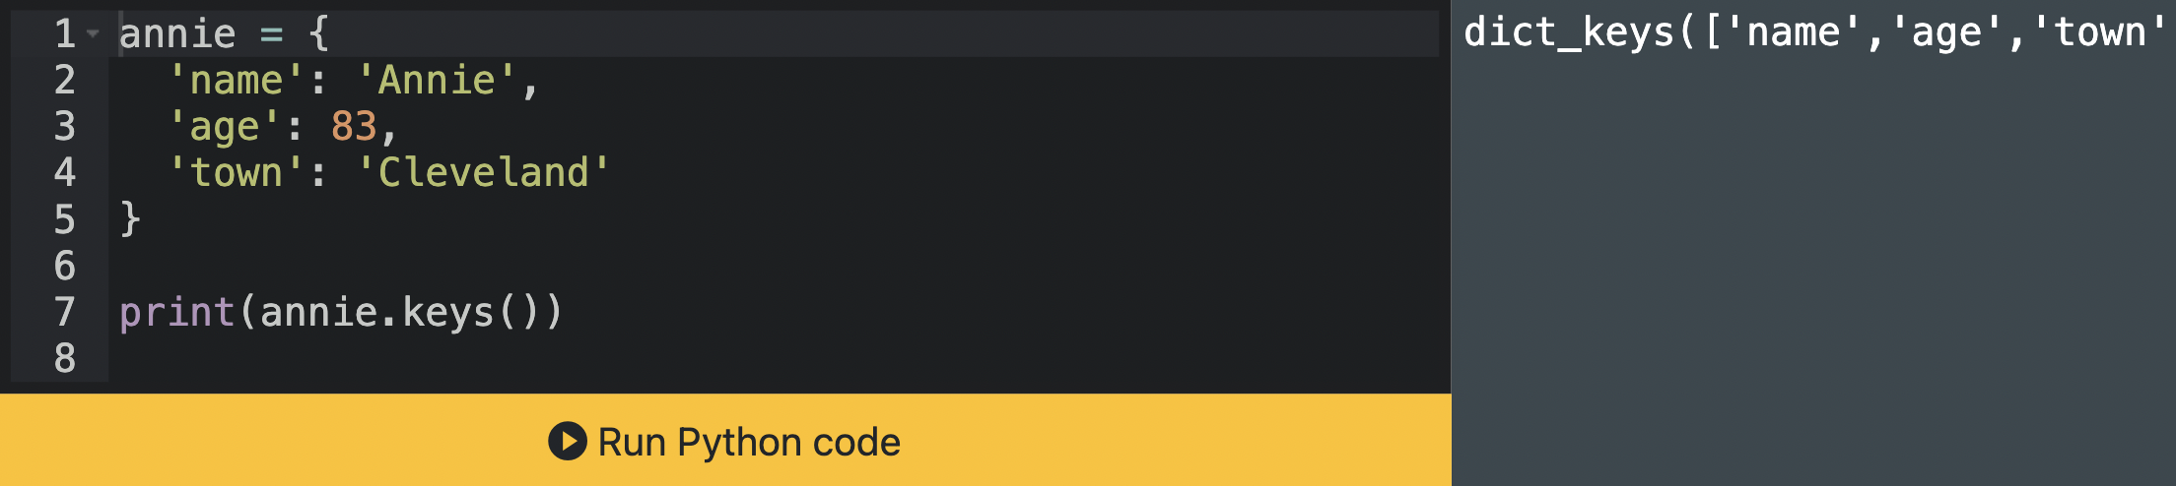

**String:**

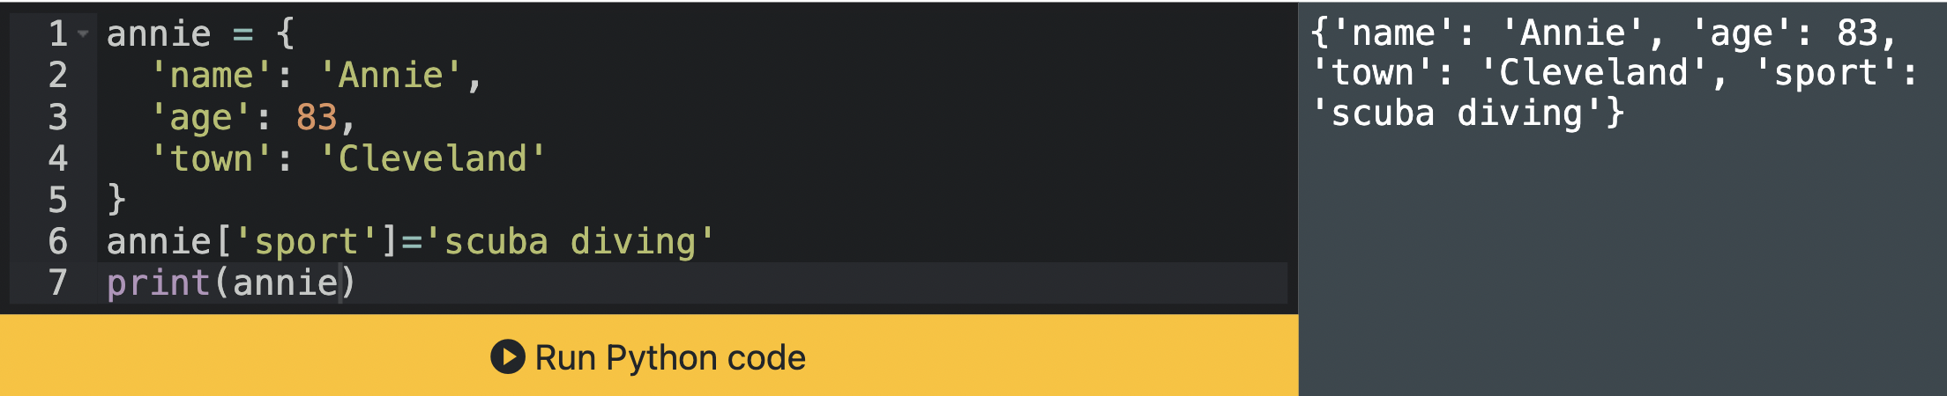

values

keys

**print(populations.values())——dict_values([7.2,1.407,1.401,12.19])**

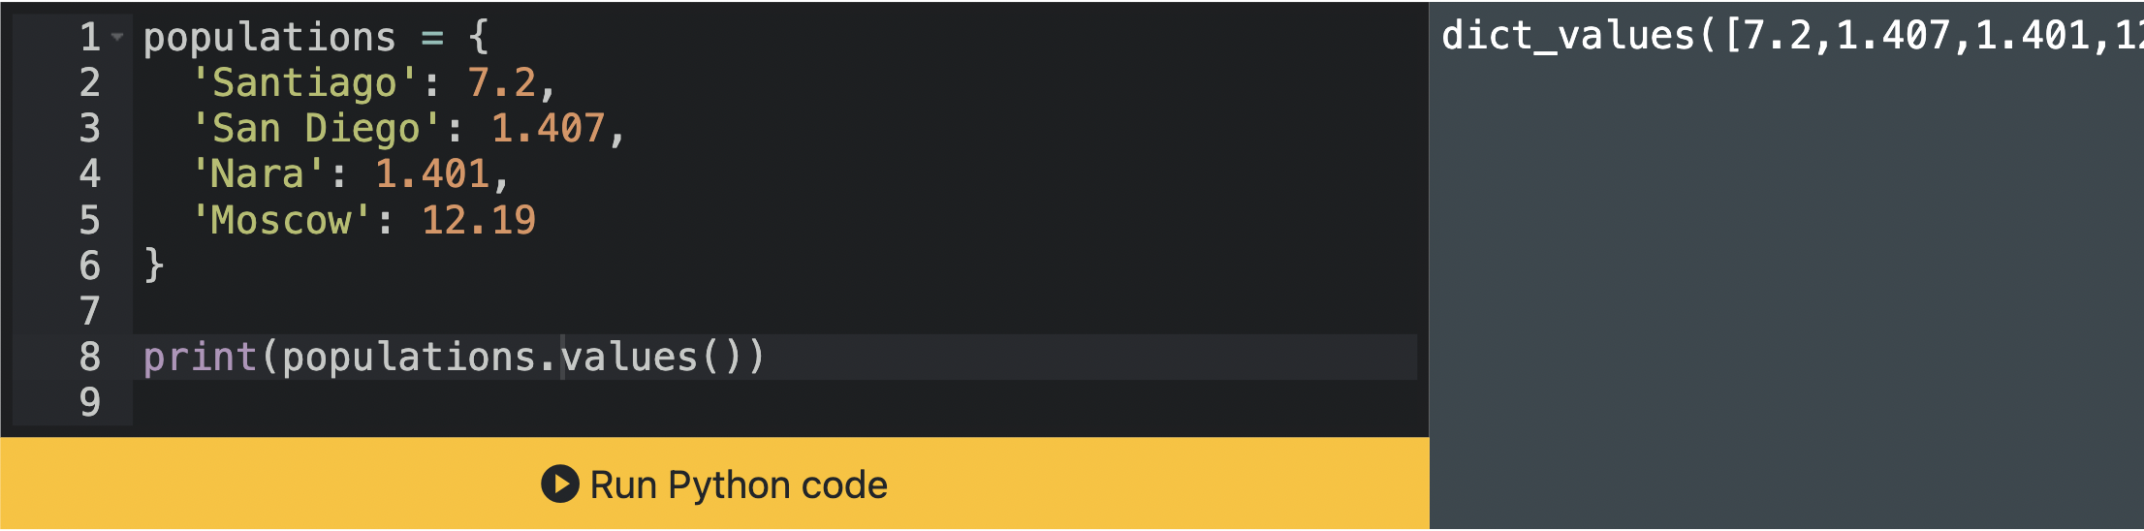

**Sum Dictionary Values: print( sum( population.values() ) )**

**Stacking on Dictionary:**

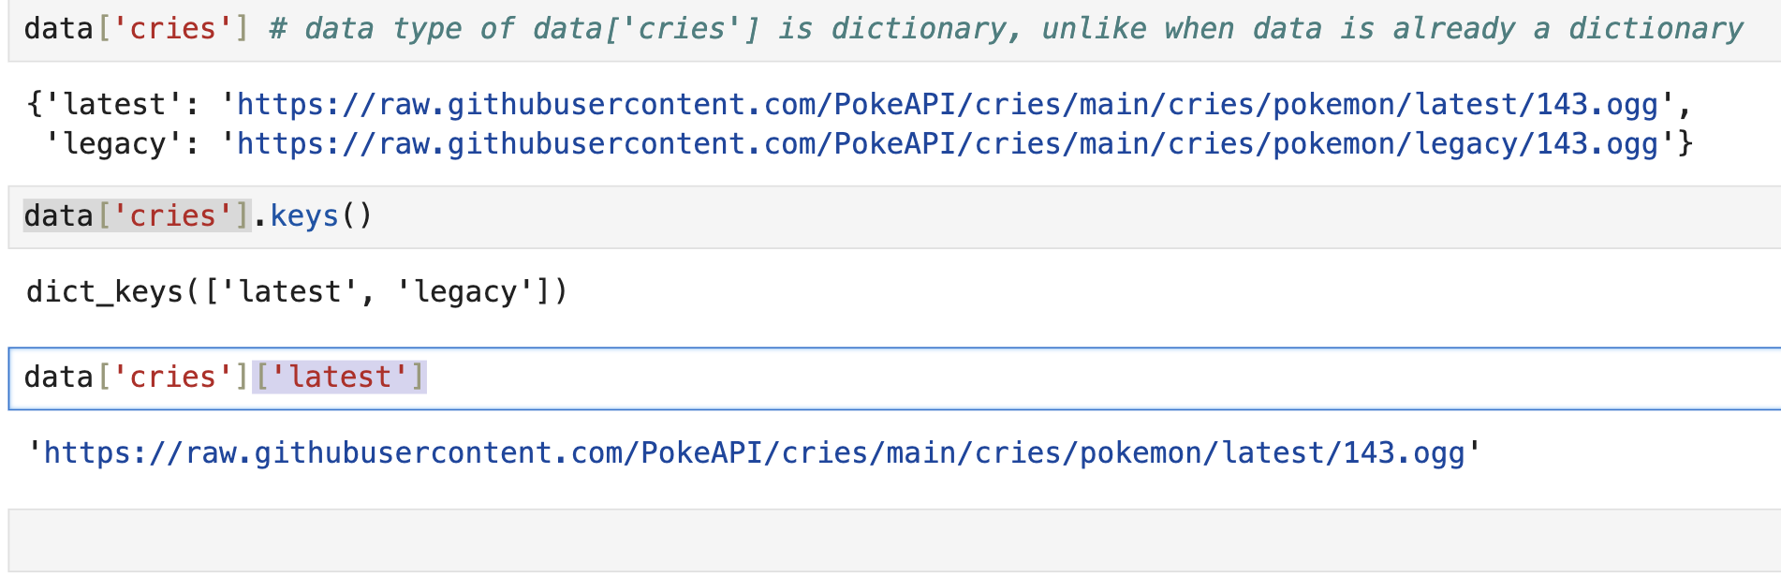

**\*\*\***

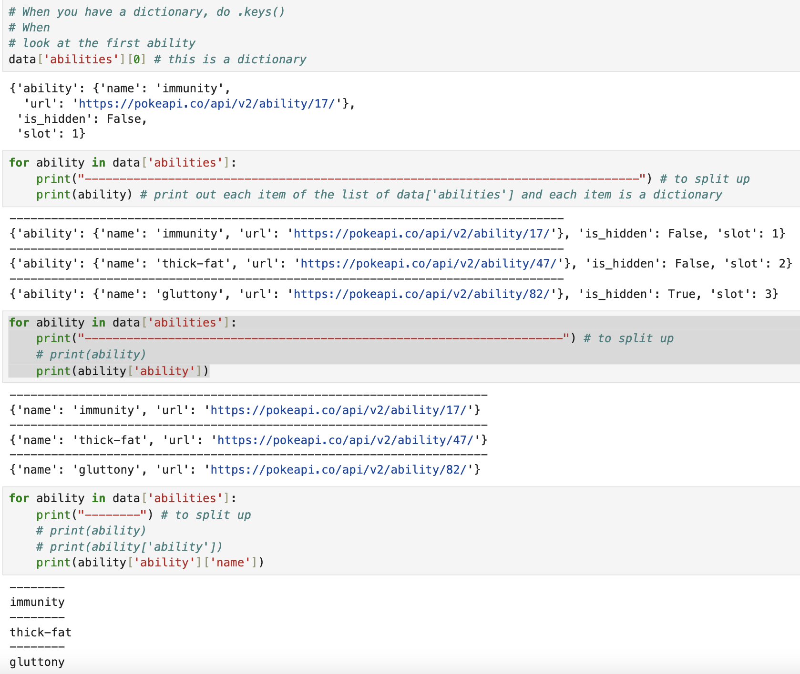

**For Loop + Dictionary:**

**-Print Keys:**

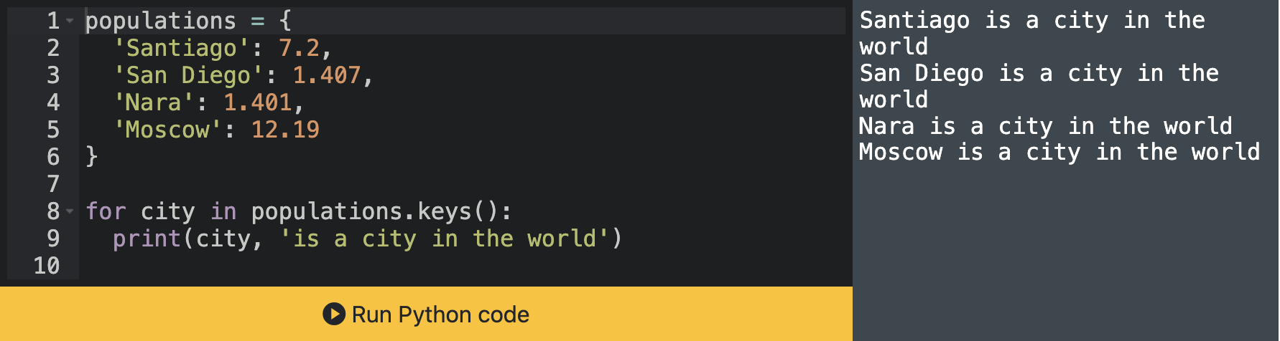

**-Print Values:**

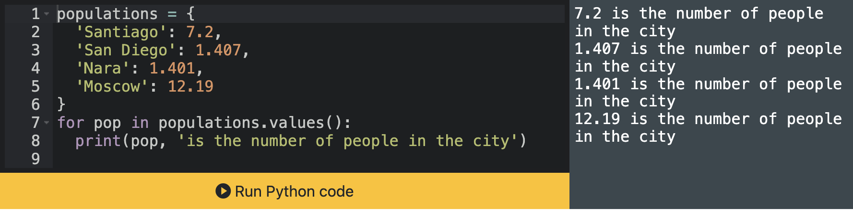

**-Print Both Keys&Values: .items()**

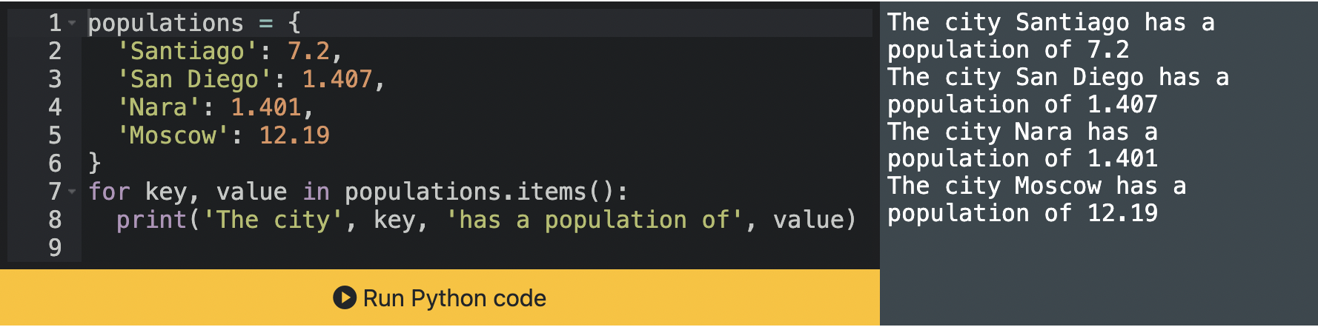

**f-strings:**

**-The string starts with f', not just ' (f" works too)**

**-The variable is inside of curly braces {}**

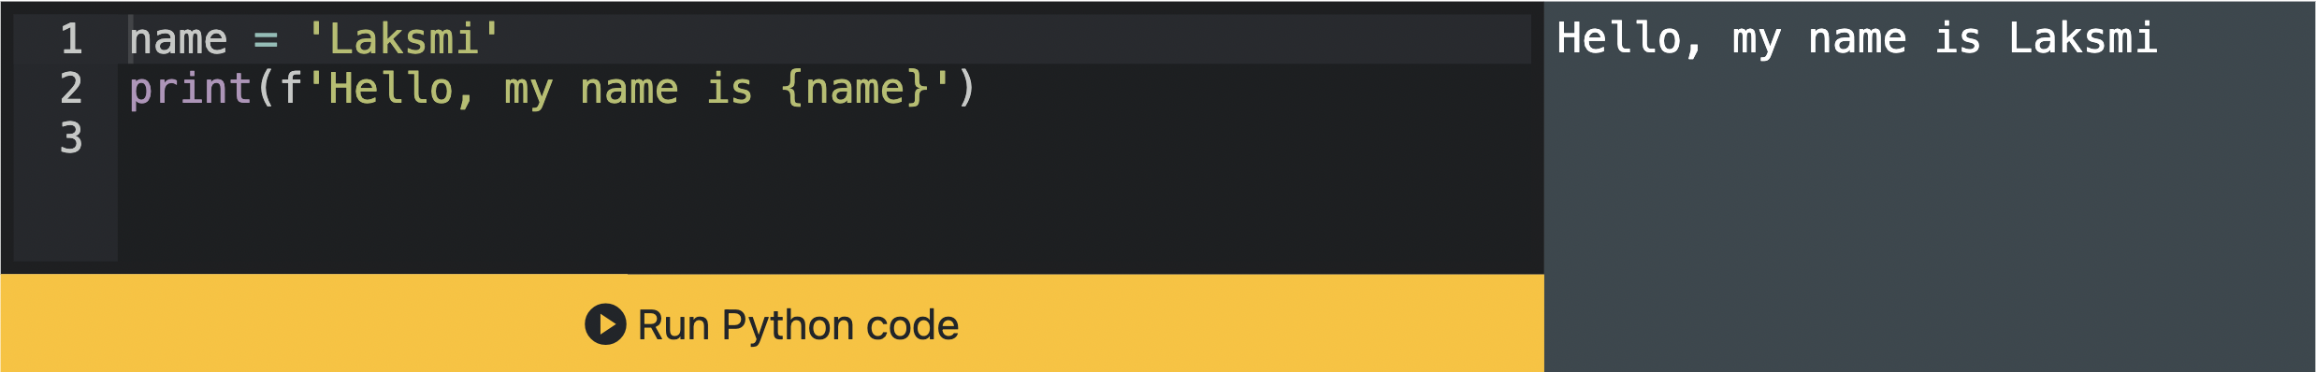

**f-string&Calculation:**

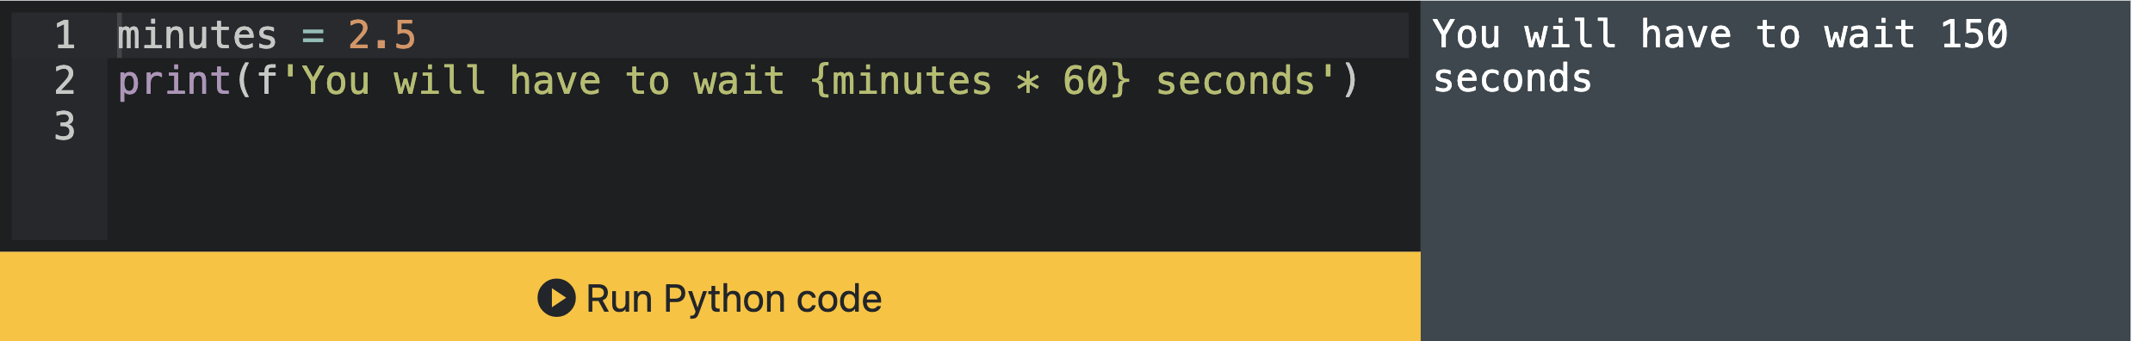

**f-string&格式：**

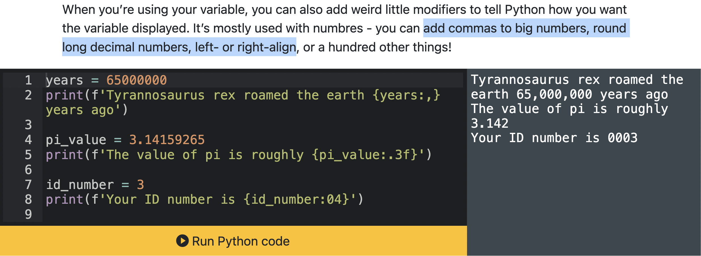

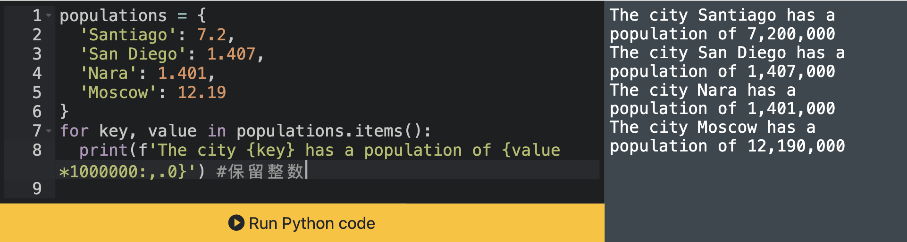

**加 # to Comment Codes**